**MUHAMMAD Hussnain Sheikh**

**FA22-BCS-011**

**BCS-C**

**Wholesale Inventory Management System**

**Bicycle parts**

**Question 1: Illustrate the complete textual description of your selected organization.**

In the present market era, efficient management is a bold key to success. Our proposed project aims to develop a wholesale Management System for bicycle products. This system will enable businesses to manage their inventory effectively, process sales and orders, and maintain accurate records of goods in the warehouse. Design a wholesale warehouse management database to keep records of inventory levels.

To ensure optimal functionality and efficiency, our system will incorporate the following business logic:

The company purchases many types of different products from many suppliers and sells them to many customers according to the orders. There are many types of each product, and each type of product has its price according to its size. Many types have a maximum of 6 sizes. If the customers want to purchase a product of a specific type of a specific size, they order the product of that type in a specific size. One customer orders many orders, and many orders contain many types of products. Employees sell the products, many employees sell many products according to the type and sizes. Capture customers who order the order including information including name, contact details, and address. Analyze Order details with all products and their types and sizes. Capture employees who make the sale including information including name, contact details, and address. Analyze sale details with all products and their types and sizes. Generate customizable reports on sales performance and customer trends. Analyze inventory turnover rates, identify slow-moving items, and optimize stocking levels for better efficiency.

**Question 2: Identify the core data storage entities (Transactional Entities)**

* **Orders details**
* **Sales details**
* **Type size details**
* **Purchasing details**
* **Price details**

**Question 3 : Draw the diagram to show the major inflows of data and outflows (Reports) of proposed system.**

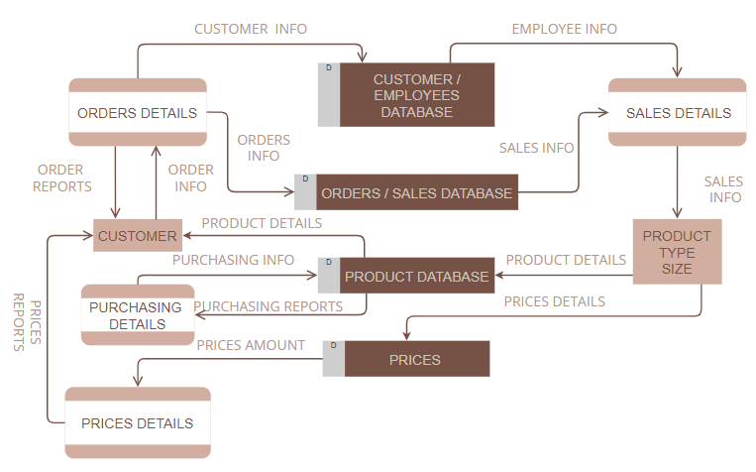

**MUHAMMAD HUSSNAIN SHEIKH FA22-BCS-011 BCS-C**